Summer Reading Newsletter 2017

Dear Parents,
During the summer holidays there are a variety of ways you can support you child with their reading.
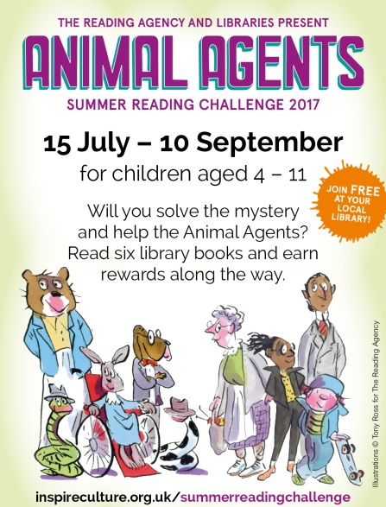
Animal Agents
Join the Summer reading challenge at your local library. Can your child read 6 books during the holiday and receive all the rewards that go with it? If you feel like joining in, there is an adult reading challenge with the chance to win some super prizes.

Reading snuggle
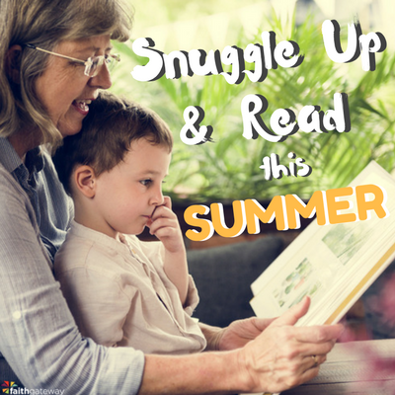
Research shows that paired reading has the biggest impact on children’s reading progress and paired reading with an adult has the greatest benefit. Being read to is important for all children, even those at upper Key Stage 2, as adults can read books that are more advanced than the child can attempt on their own. Find time to read to your children and take a photo of your reading snuggles. How many different books can you read together?

Happy reading, there are many adventures to enjoy.
Miss Meade

